**State University of New York at New Paltz**

**John Berean**

**Project Type: Internship, Student’s “Class Key”: s19-03**

**“CSTEAM Q/A System”**

**FINAL PROJECT REPORT**

**Computer Science Projects**

**Spring 2019**

**(Prof. Hanh Pham)**

**TABLE OF CONTENTS**

**1. Problem Description**

**1.1 Business Context and Goals** ….……………………………………….…………….……. page 03

**1.2 General Information** ….……………………………………….…………….……. page 03

**1.3 Project Description** ….……………………………………….…………….……. page 03

**1.4 Technical Requirements** ….……………………………………………….……….………. page 03

**1.5 Your Responsibilities** ……...……………………………………………….……….………. page 04

**2. Technologies**

**2.1 Related Technologies** ….……………………………………….……………………..…….. page 05

**2.2 Newly Learned Skills/Technologies …**………………………………..………………. page 07

**3. Design**

**3.1 System Architecture** ………………….……………………………………….………………. page 09

**3.2 Components** ………………………….…………………………………………..………………. page 10

**4. Software/System Description** ………………………………………….……………..……..…………. page 12

**5. Test Results/Observations**

**5.1 Experiment/Observation # 1** ……….…….……..………………. page 14

**5.2 Experiment/Observation # 2** ……………………….……..………………. page 15

**5.3 Experiment/Observation # 3** ……………………….……..………………. page 15

**5.4 Experiment/Observation # 4** ……………………….……..………………. page 15

**6. Professional and Career Benefits** ……………………………….……..….…….……..……………. page 16

**7. Conclusions** ………………………….……………………………………………...…………..………………. page 17

# Problem description

## 1.1 Business context and goals

CSTEAM is a web based question and answer site for students taking CS1 and CS2 at SUNY New Paltz. The goal is to create a functional website the will allow students to create an account and post questions they might have about problems, subjects or code. And in return user may also be able to respond to other questions posted by other students. The aim is to improve the learning process of students taking CS1 and CS2 similarly to Stack Overflow. But the website can eventually encompass more subjects such as CS3 or Discrete Math, based on the clients request and or student demand.

## 1.2 General Information

|  |  |
| --- | --- |
| **Date Requested** | *01/10/2019* |
| **Requested By** | *Chirak Easwaran, Hanh Pham* |
| **Email** | *jmberean@gmail.com* |
| **CO/CC** | *SUNY New Paltz Computer Science Department* |

## 1.5 Techinical requirements

Technical aspects that the system must fulfill.

* Register
* Login
* Uploading Questions
* Responding to Questions
* Searching for Questions
* Viewing All Questions
* Viewing a Single Question

**Register**

* Users may register with an account on our system. They do this by clicking the “Register” button on the top navbar, this will direct them to the “Register page”.
* Once there, potential account owners must provide their first name, last name, a unique username, email address and password.
* When submitted, the system will the use front end HTML code to verify valid entries have been entered in the first name, last name, email and password fields before passing the data to the back end. If the information is invalid, HTML code will display a relating error, keeping the user on the “Register Page”.
* Once valid data has been entered it will be passed to the register PHP code, which will attempt to insert the user’s information into the “User” table. Before doing so the function will hash the password using the MD5 message-digest algorithm producing a 128-bit hash value.
* If the username already exists in the “User” table PHP code will redirect the user back to the “Register Page” with a relating error.
* Otherwise, PHP code will insert the user’s information into the “User” table, create a login user session constructed from the username and redirect them to their “Profile Page”.
* Once a user has successfully registered they will be able to upload questions and respond to other uploaded questions. Along with all other functionalities listed above.

**Login**

* Successfully registered users may log in to their account from our website. They do this by clicking the “Login” button on the top navbar, this will direct them to the “Login page”.
* Once there, account owners must provide their username and password.
* When submitted, the system will the use front end HTML code to verify valid entries have been entered in the email and password fields before passing the data to the back end. If the information is invalid, HTML code will display a relating error, keeping the user on the “Login Page”.
* Once valid data has been entered it will be passed to the login PHP code, which will attempt to select the user’s information from the “User” table.
* To do that we must first hash the selected password using the MD5 hashing algorithm. If the username exists in the “User” table PHP code will create a login user session constructed from the username and redirect them to their “Profile Page”.
* Once a user has successfully logged in they will be able to upload questions and respond to other uploaded questions. Along with all other functionalities listed above.

**Uploading Questions**

* Successfully logged in users may upload questions from their account to the website. They do this by clicking the “Post” button located on the top navbar and bottom left of the “Profile Page”, this will direct them to the “Upload Page”.
* When directed there, users must provide valid information about a there question in the form of text.
* Once submitted, the system will the use front end HTML code to verify valid entries have been entered in the text fields before passing the data to the back end. If the information is invalid, HTML code will display a relating error, keeping the user on the “Upload Page”.
* Once valid data has been entered it will be passed to the upload PHP code, which will attempt to insert the questions information into the “Question” table.
* Once a user has successfully uploaded a question the will be redirected to their profile page.

**Searching for Questions**

* Users may search for Folios based on selected attributes. They do this by clicking the “Browse” button on the top navbar, this will direct them to the “Browse Page”.
* Once there, users must select an Edition and owner to filter the Folios by.
* Once data has been selected it will be passed to the search PHP code, which will attempt to select from the “Folio” table where the edition and owner fields matche.
* If no Folios match in the “Folio” table PHP code will display a message informing the user that no results have been found.
* Otherwise, PHP code will direct the user to the “Browse Results Page” with the resulting Folio matches.
* From there the user may go back to the “Browse Page” or select a folio to view.

**Viewing All Folios**

* Users may view all Folios in our records. By clicking the “Folios” button on the top navbar, this will direct them to the “Folios Page”.
* The “Folios Page” display all the folios in a three-column long table. Each column contains the SFP Number, Edition and Owner accordingly.
* Once there, users may sort the table according to SFP number, Edition or Owner.
* They may also use the search bar located above the table to search based on to SFP number, Edition or Owner.
* When a user selects an individual folio from the “Folios Page” PHP code will create a current folio session to render the designated folio on the “Folio Page”.
* The user will then be directed to the corresponding “Folio Page”.

**Inviting Collaborators**

* Users will be able to invite other registered users to collaborate on their uploaded folios.
* These collaborators may alter and or add information/pictures to the folios that they are given permission to.
* Collaborators may only edit posted folios not delete them.
* The deleting of folios operation is entitled to the original user that posted the folio along with editing.
* This is done by clicking the “Invite Collab” button located on the left navbar of a “Folio Page”.
* Once there a register username must be inserted to invite. Once submitted HTML code will verify an entry has been made before passing the data to the PHP code.
* If a valid entry has been submitted PHP code will attempt to verify he user is not already a collaborator on the folio by selecting the username from the “Collaborator” table.
* If the username already exists, the user will be redirected back to the “Invite Collaborator Page” with a relating error message.
* Otherwise the username will be inserted into the “Collaborator” table and the user will be redirect back to the corresponding “Folio Page” with a message about successfully inviting the user.

**Collaborating**

* Successfully logged in users may collaborate on other folios they have been invited to.
* This is done by clicking the “Collab” button located on the left navbar of a “Folio Page”.
* Once clicked, the user will be directed to the “Collaborate Page” which will contain all of the folio’s information in the form of editable text boxes.
* They may either update, edit or add information from there.
* When submitted, the system will the use front end HTML code to verify required entries have been entered before passing the data to the back end. If the information is invalid, HTML code will display a relating error, keeping the user on the “Collaborate Page”.
* Once valid data has been entered it will be passed to the collaborate PHP code, which will attempt to set the new folio information in the “Folio” table.
* Once done the user will be directed back to the corresponding “Folio Page” with a message about the successful collaboration.

## 1.5 YOUR RESPONSIBILITIES

* Communicate with the client Chirak Easwaran to assure that the application meets the organizations objectives.
* Conduct multiple requirements analysis with the client Chirak Easwaran and acting manager Hanh Pham.
* Develop the reports and documentation for the system.
* Provide the manpower to design and develop the web-based application. Given other concurrent commitments, the development of this system took approximately 4 months.

## 2. technologies

## 2.1 related technologies

***HTML 5*** *– Markup language*

* HTML 5 is a software solution stack that defines the properties and behaviors of web page content by implementing a markup-based pattern to it.
* HTML 5 is the fifth and current major version of the HTML standard and subsumes XHTML.

***CSS*** *– Stylesheet language*

* Cascading Style Sheets is a style sheet language used for describing the presentation of a document written in a markup language like HTML.
* CSS is a cornerstone technology of the World Wide Web, alongside HTML and JavaScript.

***Bootstrap*** *- Front-end framework*

* Bootstrap is a free and open-source CSS framework directed at responsive, mobile-first front-end web development.
* It contains CSS and JavaScript-based design templates for typography, forms, buttons, navigation and other interface components.

***JavaScript*** *- High-level programming language*

* JavaScript, often abbreviated as JS, is a high-level, interpreted programming language that conforms to the ECMAScript specification. JavaScript has curly-bracket syntax, dynamic typing, prototype-based object-orientation, and first-class functions.

***PHP*** *– Programming language*

* PHP: Hypertext Preprocessor is a general-purpose programming language originally designed for web development.

***MySQL*** *– Database / System software*

* MySQL is an open-source relational database management system.

## 2.2 NEWLY LEARNED SKILLS/TECHONOLOGIES

Working on further developing my skills with PHP, MySQL and the intermingling of the two.

## 3. design

## 3.1 System architecture

## https://documents.lucidchart.com/documents/d9ce840f-bbb8-4173-b7ea-4f1b70fb5d11/pages/0_0?a=8707&x=-114&y=43&w=3828&h=3461&store=1&accept=image%2F*&auth=LCA%207ff58ca97a029150e4ccea27755c85cc8ba1f9b2-ts%3D1556905407

## 3.2 components

Register

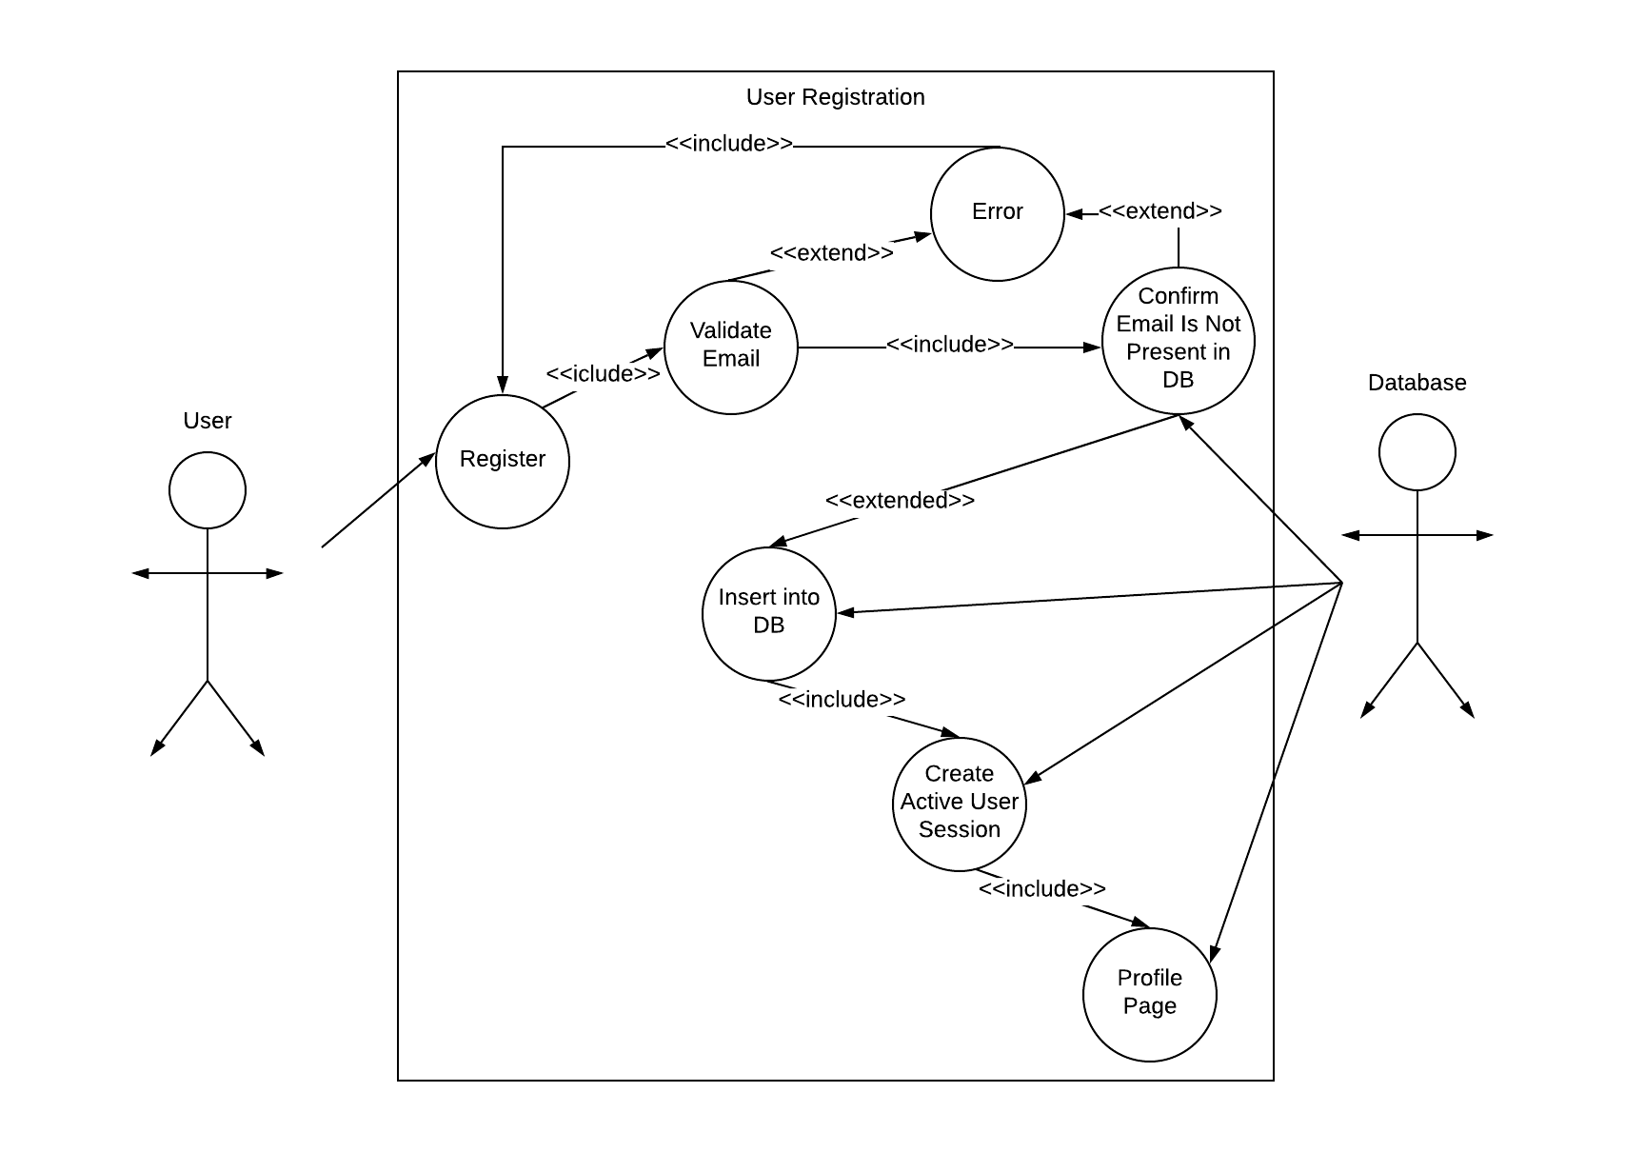

Login

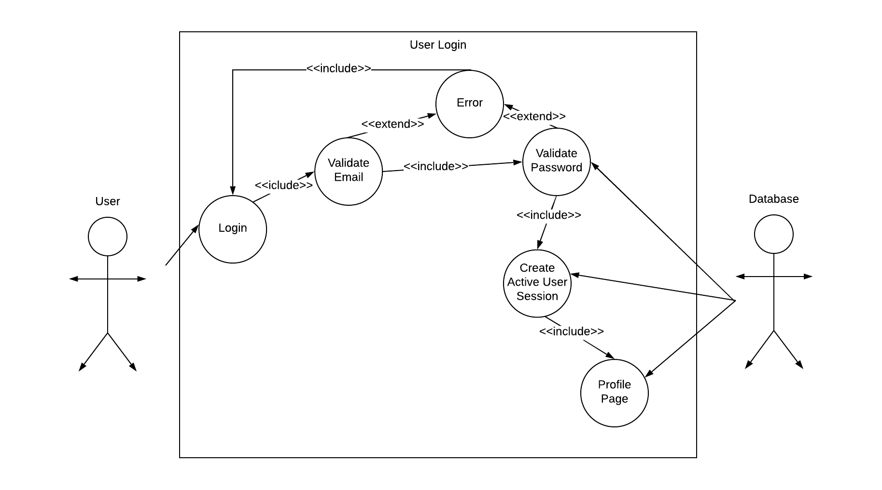

Uploading Folios

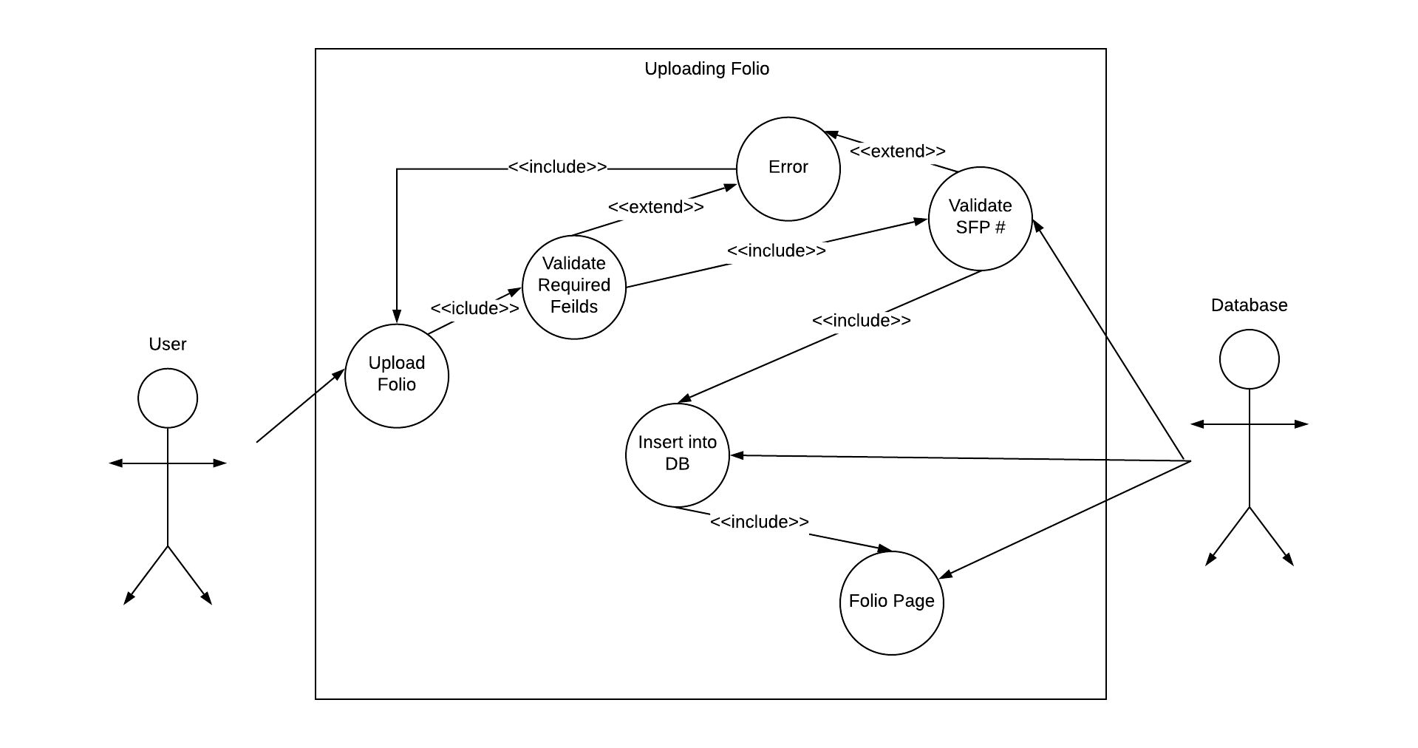

Collaborating

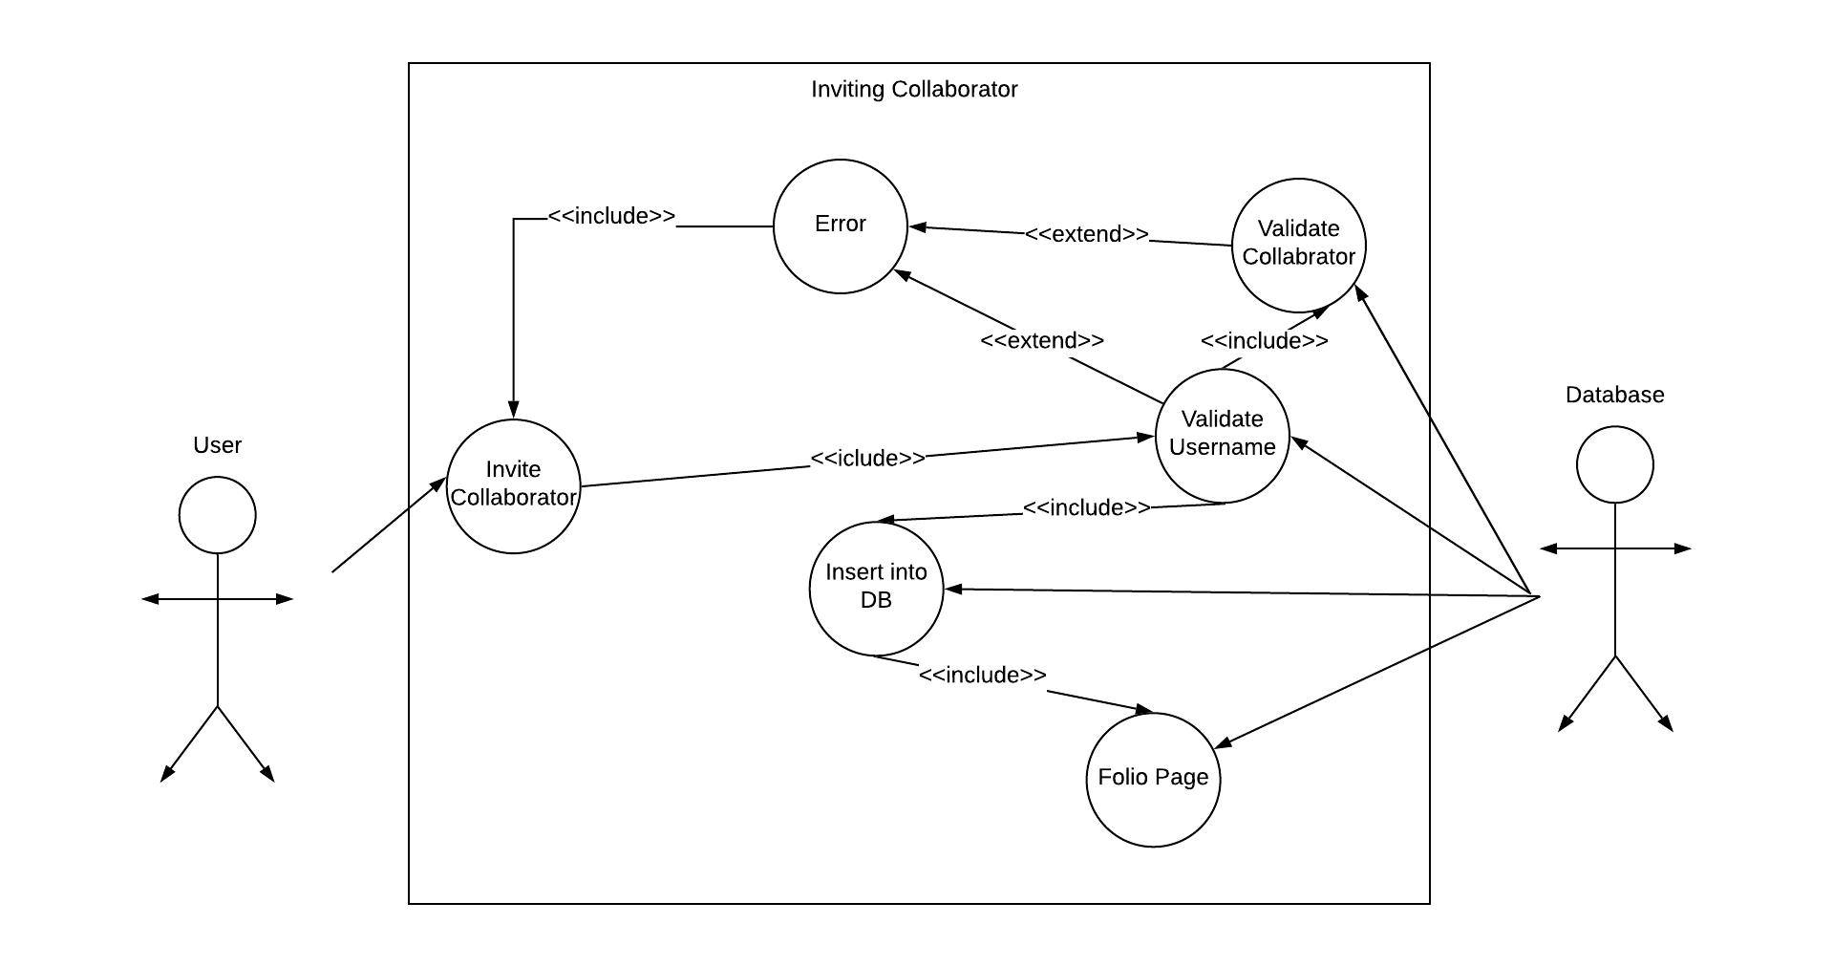

## 4. software/system description

The proposed Shakespeare Folios system will consist of a web-based, centralized database.

Generally, all users will provide direct input (Folios) into the system and outputs will also be generated directly from the system. However, to ensure growth ability, flexibility is also required for both input and output modes.

Participating administrators will have control over the system and database. The system is planned to be developed by myself.

|  |  |
| --- | --- |
| **Name** | *The Shakespeare Folios Project* |
| **Desired Start Date** | *1/20/2019* |
| **Business Need** | *The Shakespeare Folios Project seeks to identify all existing copies of Shakespeare’s Second, Third, and Fourth Folios. Why? The First Folio has been thoroughly studied and counted, and thanks to the work of generations of scholars, we know how many copies exist today (around 235) and where they are located. But we don’t know how many copies of the later folios there are. Scholars make assertions about the scarcity of the Third Folio, but is it scarce? If we want to study how Shakespeare’s publications evolved and how they were used, we need first to identify where to find them.* |
| **Goals/Scope** | *The Shakespeare Folios Project seeks to identify all existing copies of Shakespeare’s Second, Third, and Fourth Folios.* |
| *By creating a platform for scholars and literarians to actively participate in the identification of all existing copies of Shakespeare’s Second, Third, and Fourth Folios.* |
| **Risks/Issues** | *The issue of authentic information is crucial for the validity of the websites data. Therefore we have given Cyrus Mulready complete control of the website in order to modulate the activities and information inserted.* |

**5. Test Results/Observations**

**5.1 Experiment/Observation # 1 (Viewing Folios)**

|  |  |
| --- | --- |
| 1 |  |
| 2 |  |
| 3 |  |

**5.2 Experiment/Observation # 2 (Uploading Folios)**

|  |  |
| --- | --- |
| 1 |  |
| 2 |  |
| 3 |  |

**5.3 Experiment/Observation # 3 (Register/Login)**

|  |  |
| --- | --- |
| 1 |  |
| 2 |  |
| 3 |  |
| 4 |  |

**5.2 Experiment/Observation # 2 (Collaborating)**

|  |  |
| --- | --- |
| 1 |  |
| 2 |  |
| 3 |  |
| 4 |  |
| 5 |  |
| 6 |  |
| 7 |  |

**6. Professional and Career Benefits**

* *Strengthened my web development skills.*
* *Improved on the programming languages (PHP, MySQL, HTML, CSS).*
* *Reinforced my presentation skills.*
* *Improved my ability to plan, design and implement a software system.*

**7. Conclusions**

***Great project and experience creating a system that will go to real world use. It was difficult at times and easy at others but all around improved my strengths with web development. I only wish I experienced this side of Computer Science much earlier in my time at SUNY New Paltz.***